*Section 5 Post Prototype*

To improve the design of my system I will create another questionnaire and ask my peers and the staff of Meigh Pharmacy to give feedback on the prototype:

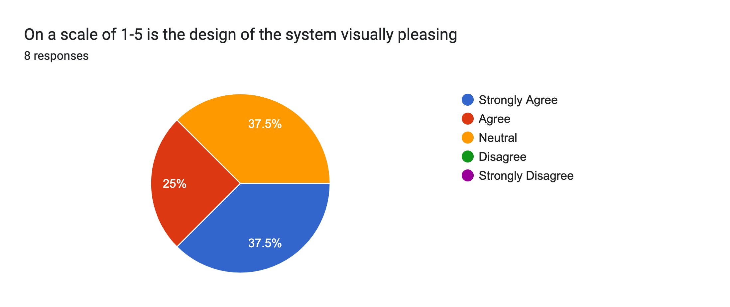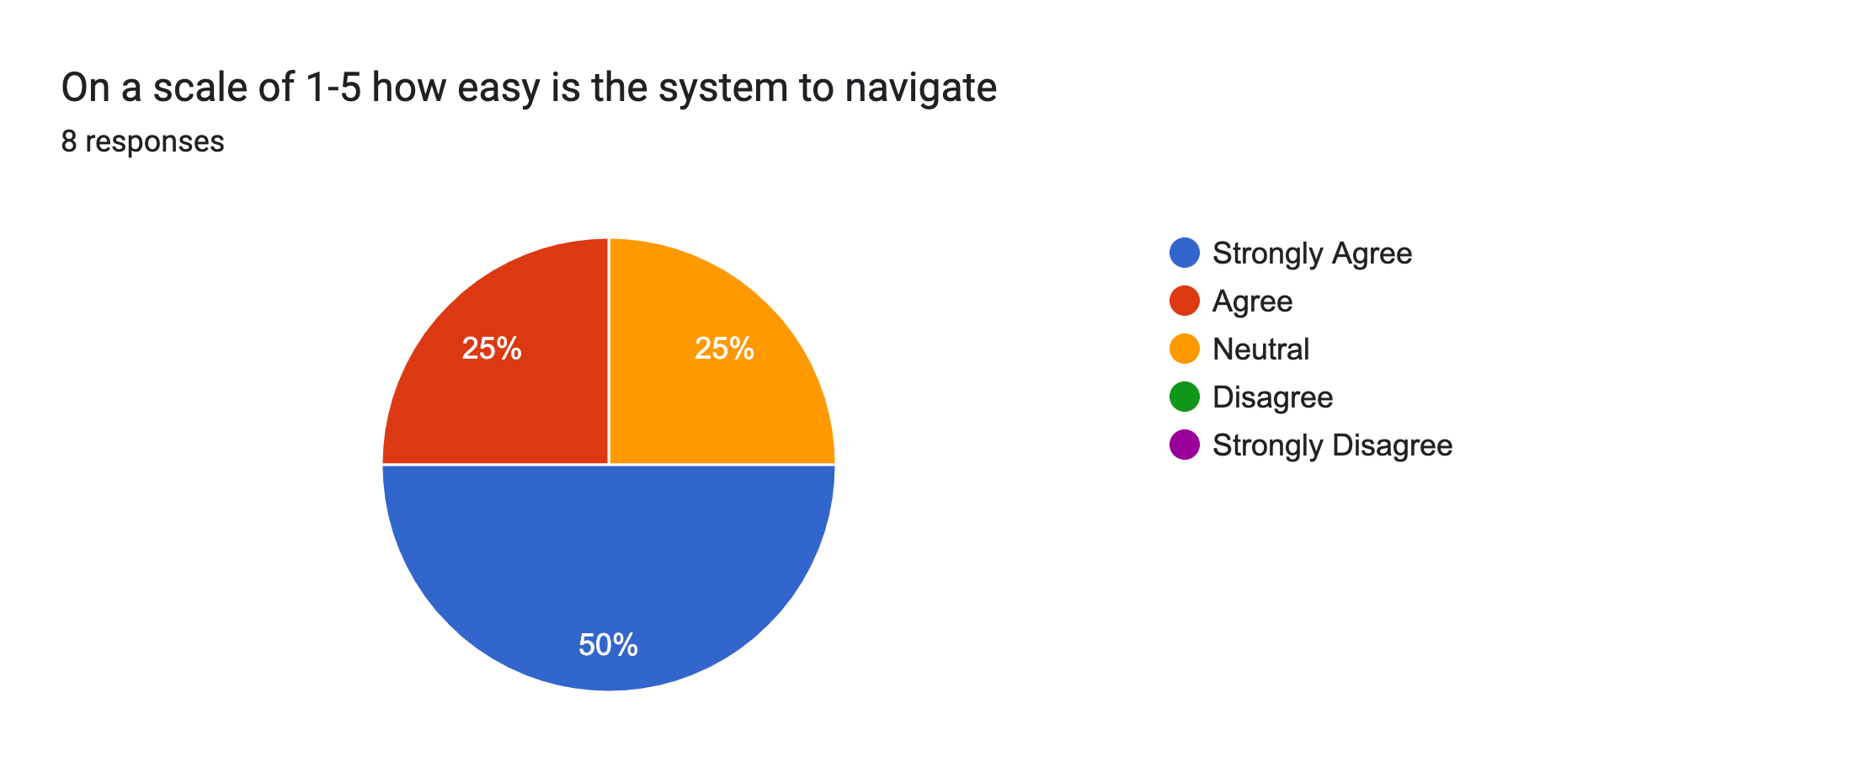

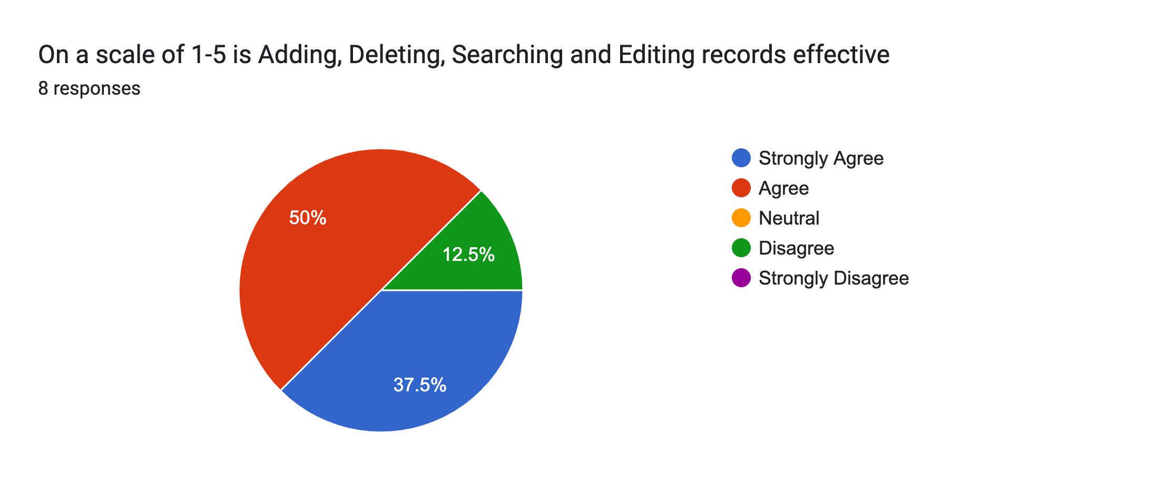

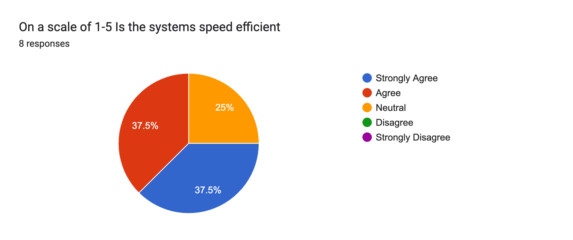

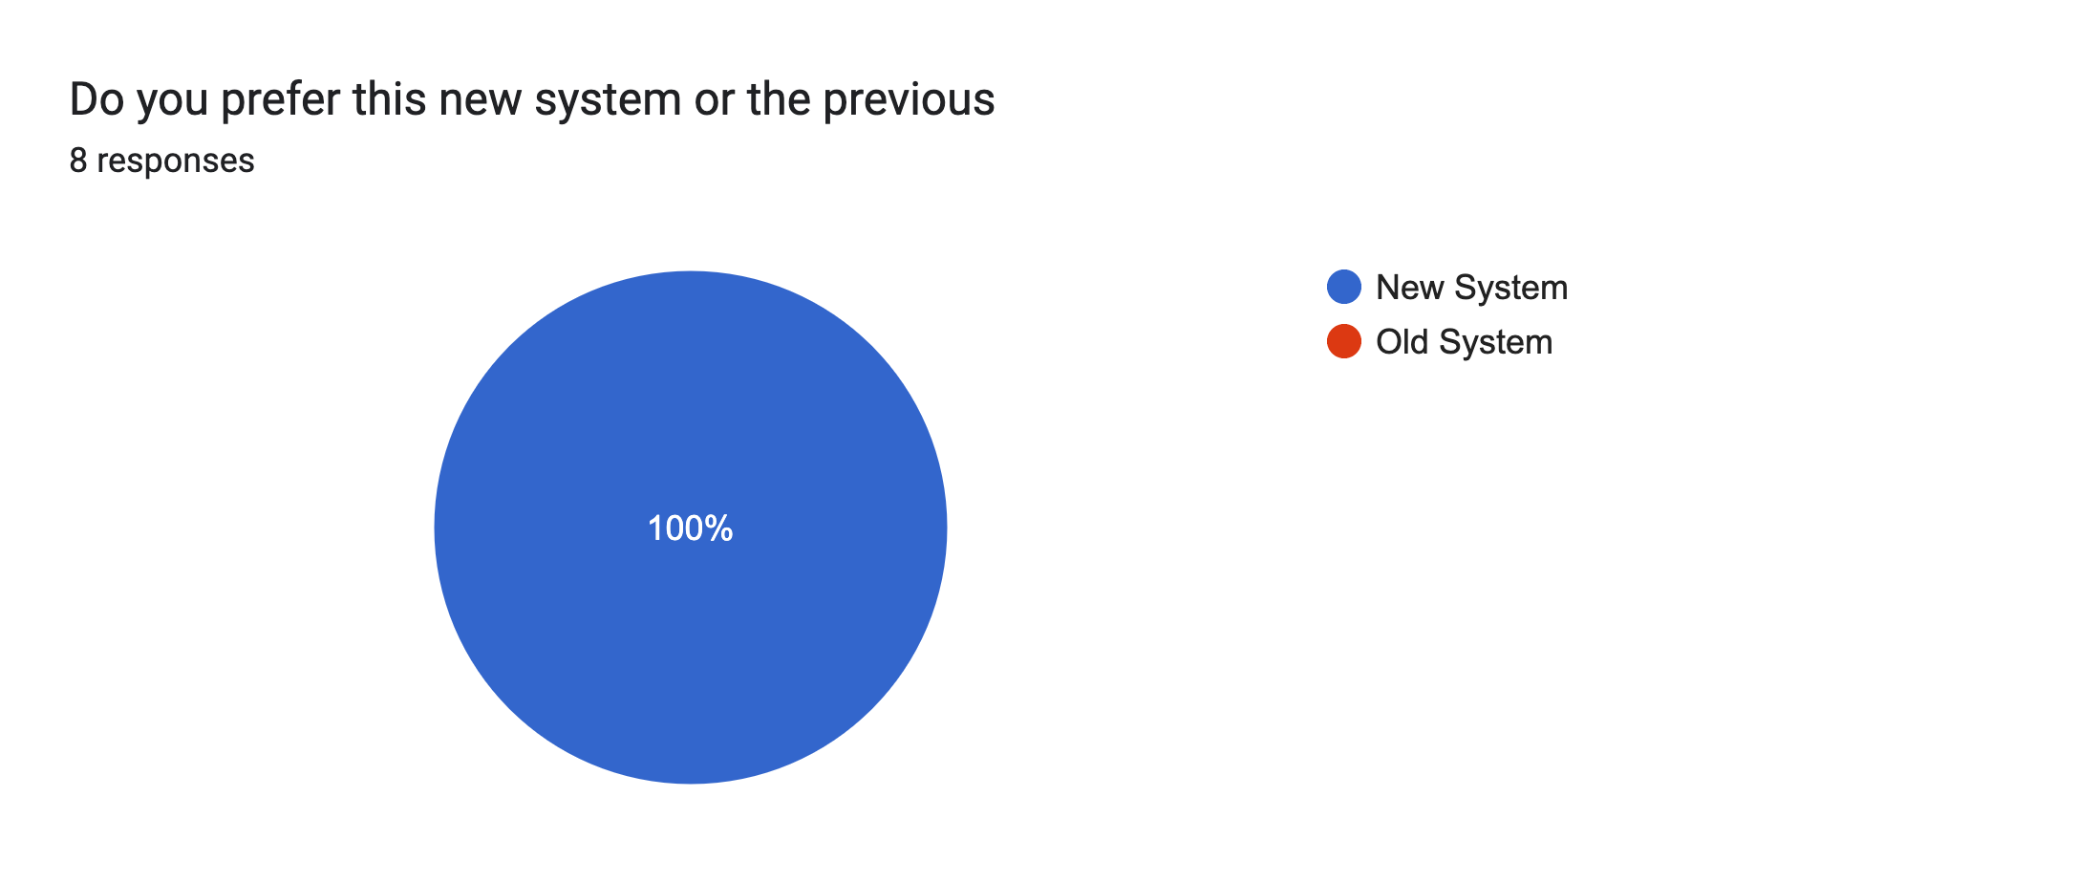

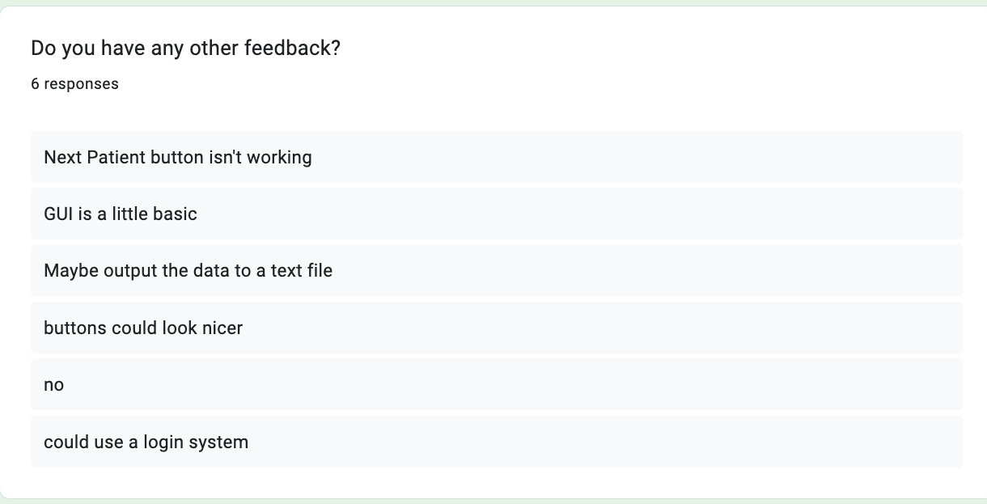

**Feedback from the Questionnaire**

**System Usability**

With the use of a tabbed window feature the code is efficient and clutter has been minimized while maintaining easy access to certain system features.

**User Interface**

It seems that some users find the UI hard to navigate and not as simple as they would like, however I believe some training and practice in the system would change theirs views.

**Aesthetic Design**

While the aesthetics of the system are very important for the final product, in the prototype I am more worried about the actual functionality of the system itself. I will also prioritize the development of more important functions such as the login system, due to time constraints.

**Entry Fields**

The entry fields seem to be very well developed; however, the buttons do seem to be better developed aesthetically.

**System Responses**

The systems’ responsiveness to user actions, such as searching using buttons, has been positive. The feedback from the system after an action has occurred helps users understand how to use the overall system and this is a positive.

**Additional features to add to the Final Design**

There is two different features that I will implement to my final solution’s design. One is a login system for the Main Menu GUI as well as a way to output the data in the database for the user to view such as outputting to a text file.

**Login Screen to the Main GUI**

The login screen will need a username and password, as well as access levels through the use of UserType column in my new table called Login Details.

Below is the table:

Username(TEXT, PRIMARY KEY)

Password(TEXT)

UserType(TEXT)

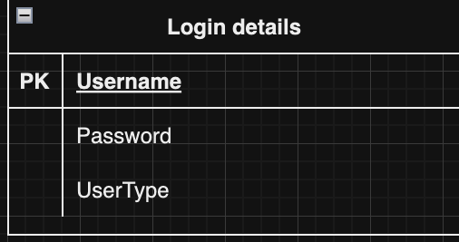

**Processing Routine for GUI**

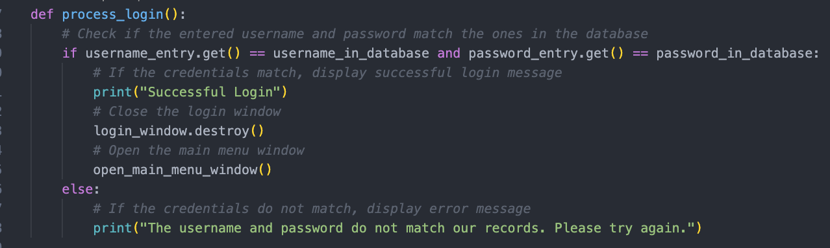

**Creation of Outputs to a text file**

I would also like the user to be able to view the data in the actual database itself by having code and buttons that create a text file to store certain table data.

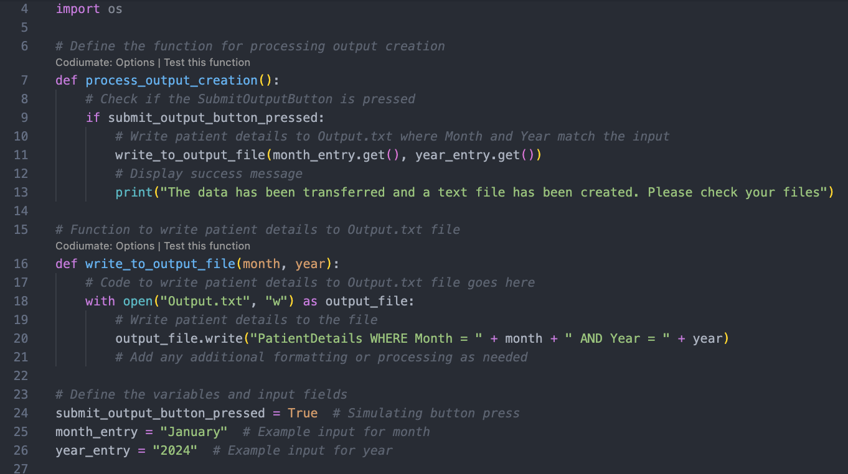**Processing routine for Text file Output**